LOYOLA JESUIT SECONDARY SCHOOL
2025/26 JUNIOUR CERTIFICATE MOCK EXAMINATIONS
AGRICULTURE
FORM 2
(100 marks)
DATE:.______________ TIME:. 2hours
Instructions
- This paper has 13 printed pages. Please check.
- Write your name at the top of each page
- This paper contains three sections: A, B and C. Answer all questions in each section
- Section A should be answered by encircling the letter with the correct answer.Section B and C should be answered in the spaces provided.
- tick against the question number you have answered

Question  Number | Tick if  answered | Do not write in these columns
1-5
6-10
11-15
16-20
21
22
23
24
25
26
27
28
29
30
31
32
33

SECTION A

- Which of the following is an example of a cultural pest control practice?
  - Timely planting
  - dusting
  - hand picking
  - using predators
- Why is it advisable to have a control in an
experiment?
  - to avoid environmental interferences
  - to obtain equal results in the
experiment
  - to avoid human bias in the
experiment
  - to compare the treatments in the experiment
- Which of the following crop husbandry practices helps crop residues to rot and form humus?
  - early planting
  - correct spacing
  - crop rotation
  - early land preparation
- What name is given to a farming system when maize is grown together with trees?
  - shifting cultivation
  - mixed farming
  - agro forestry
  - mixed cropping
- Which of the following is part of a report of an agricultural experiment?
  - salutation
  - introduction
  - replication
  - randomization
- Army worms damage maize crops by eating
  - roots.
  - tassels.
  - cobs.
  - leaves.
- Which of the following is an effect of overgrazing?
  - high infiltration and low runoff
  - high infiltration and high runoff
  - low infiltration and low runoff
  - low infiltration and high runoff
- What is the name of the feed given to pigs that are ready for the market?
  - creep feed
  - grower’s mash
  - fattener meal
  - weaner meal
- Which of the following management practices is done in poultry?
  - thinning
  - dipping
  - farrowing
  - debeaking
- Which of the following form the three types of surface irrigation?
  - sprinkler, flood and basin
  - flood, basin and furrow
  - basin, furrow and sprinkler
  - furrow, sprinkler and flood
- Which of the following breeds of pigs is a local breed?
  - Spotted black
  - Berkshire
  - Hampshire
  - Saddle back
- An “equilibrium price” is the
  - selling price
  - highest price
  - lowest price
  - market price
- Which of the following is a minor factor of production?
  - capital
  - land
  - climate
  - labour

A sample of garden soil was dried until it had constant weight. The results are shown below:
Weight of soil before drying = 20g
Weight of soil after drying = 15g
Use this information to answer Questions 14 and 15.

- The aim of the experiment was to find out the amount of
A. humus in the soil.
  - water in the soil.
  - air in the soil.
  - living organisms in the soil.

- What was the percentage of the soil constituent found in the experiment?
  - 25
  - 50
  - 40
  - 75

Figure 1 is a diagram of a parasite of animals. Use it to answer Questions 16 to 17.
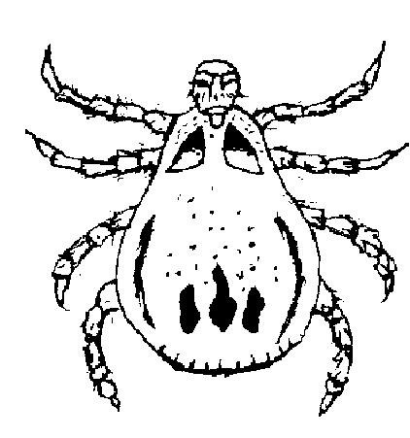
Figure 1
- What damage does this parasite cause to animals?
  - It sucks blood.
  - It sucks digested food.
  - It destroys tissues.
  - It damages the skin.

- Which of the following diseases does the parasite transmit in animals?
  - gumboro
  - anaemia
  - new castle disease
  - African swine fever
- One hectare of land is equivalent to
  - 1 000 m²
  - 100 m²
  - 10 000 m²
D. 1 000 000 m²
- Which of the following factors does not influence soil formation?
  - time
  - climate
  - capital
  - topography
- Which of the following diseases is sow likely to develop if piglets teeth are not trimmed
  - anaemia
  - African swine fever
  - Mastitis
  - Diarrhoea

Section B (60 marks)
Figure 2 is a digestive system of a pig. Use it to answer Questions 21 and 22.
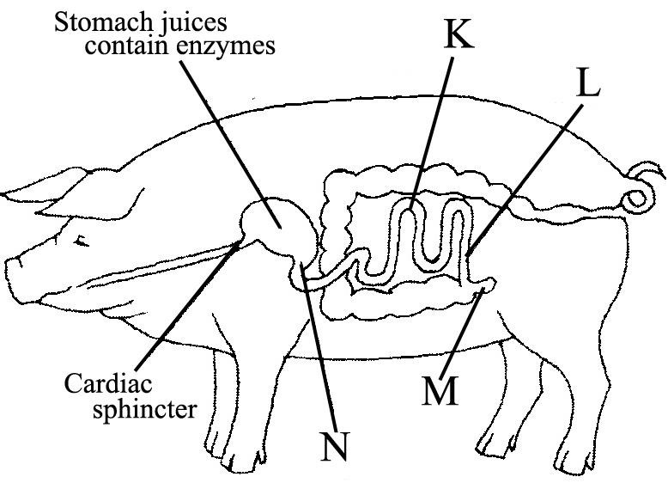
Figure 2
- Identify the part labelled N and K
N:______________________________ (1 mark)
K:______________________________ (1 mark)

- Give one function of the part labelled M
________________________________________________________________________________________________________________________ (1 mark)

- A farmer growing cabbages kept the following record for the enterprise:
      - bought seed K 200.00
      - bought fertilizer K1000.00
      - bought insecticides K 300.00
      - labour charge K 500.00
      - price per head of cabbage K 50.00
- Calculate the total income if the farmer produced 300 heads of cabbages and sold them all.

(3 marks)
- Calculate profit/loss for the farmer.

(3 marks)
- A farmer planted groundnuts at 40 cm between planting stations on ridges spaced at 90 cm apart.
- If one seed per planting station was sown, calculate the plant population per hectare.

(5 marks)
ii. Calculate the germination percentage if a farmer planted 1000 seeds and only 150 seeds failed to germinate

(4 marks)

- Figure 3 is a diagram showing a diseased broiler chicken. Use it to answer the questions that follow.
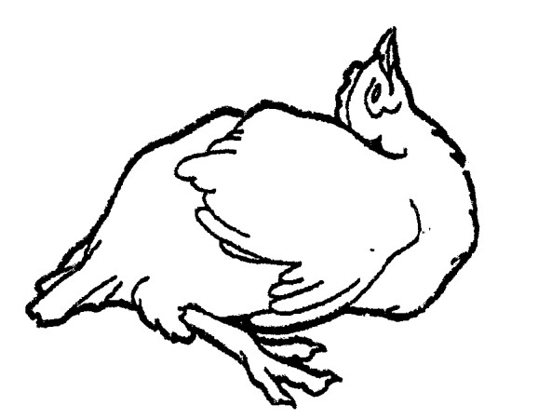
Figure 3
  - Name the disease the chicken is suffering from.
__________________________________________________(1 mark)
  - State any two symptoms of the disease.
__________________________________________________________________________________________________________ (2 marks)

  - List any two ways of controlling the disease.
___________________________________________________________________________________________________________________________________________________________________ (2 marks)

- a. Define agricultural research
________________________________________________________________________________________________________________________________________________________________________________________ (1 mark)
b. Give One examples of each of the following
    - Root vegetables
___________________________________________________ (1 mark)
    - Fruit vegetables
___________________________________________________ (1 mark)
- Explain one way in which each of the following is important in animal production
- Farm records
________________________________________________________________________________________________________________ (1 mark)
ii. budgeting
________________________________________________________________________________________________________________ (1 mark)
- a. Define the term “gender roles” in agriculture
________________________________________________________________________________________________________________________________________________________________________________________ (1 mark)
  - State any two factors that may hinder the achievement of food security and self sufficiency
________________________________________________________________________________________________________________________________________________________________________________________ (2 marks)
  - Explain any two qualities of a good pig house
________________________________________________________________________________________________________________________________________________________________________________________________________________________________________________________________________________________________________________________ (4 marks)
- a. Give any two reasons necessary why it is important to write a report after conducting an experiment
________________________________________________________________________________________________________________________________________________________________________________________________________________________________________________________ (2 marks)
- Explain any two roles of Agro-based industries in supporting the growing population
________________________________________________________________________________________________________________________________________________________________________________________________________________________________________________________________________________________________________________________________________________________________________________________________________________________________________________________________________________________________________________________________________________________________________________________________________________________________________________________ (4 marks)

- Figure 4 shows a method of fertilizer application in crops.
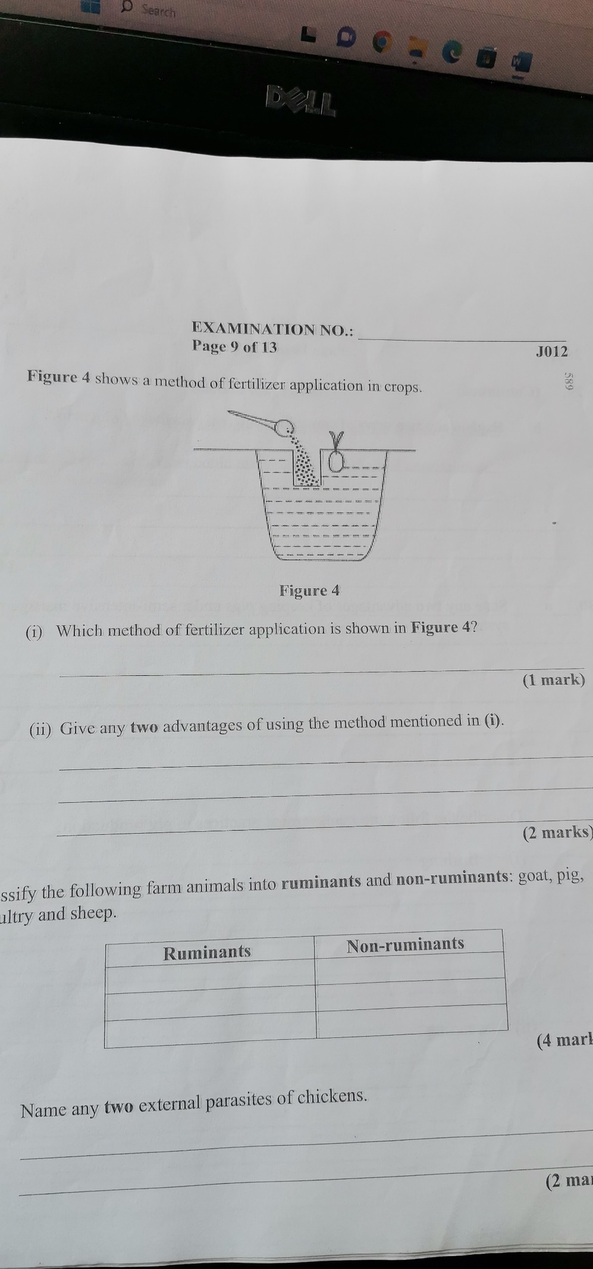
Figure 4
- Which method of fertiliser application is shown in figure
________________________________________________________ (1 mark)
- Give any one advantages and one disadvantage of using the method mentioned above
___________________________________________________________________________________________________________________________________________________________________________________________________________________________________________________________________________________________________________________ (2 marks)

- Figure 5 is a farm equipment. Use it to answer the question that follow
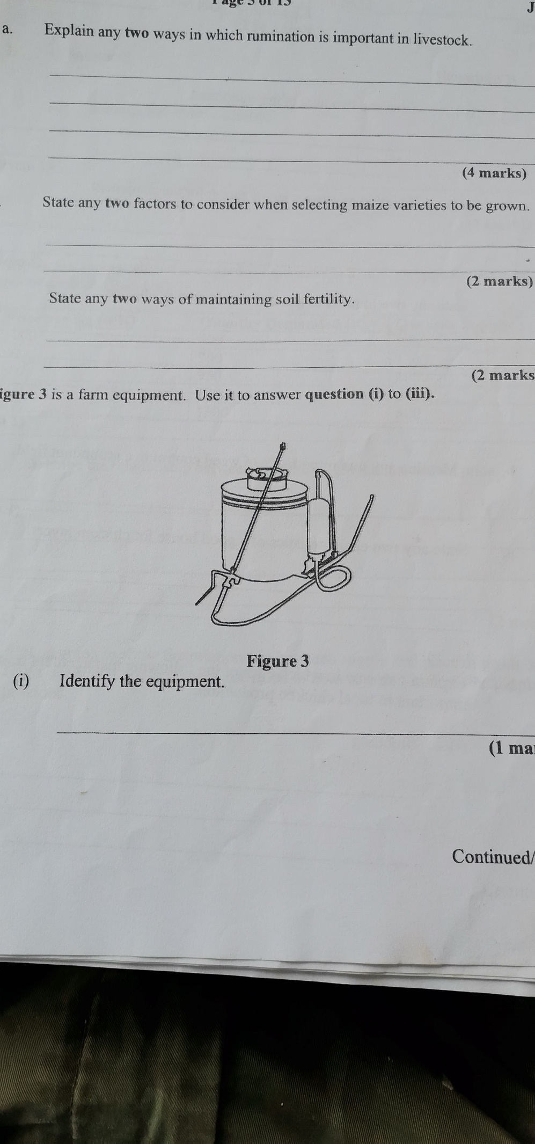
Figure 5
- Identify the equipment
_______________________________________________________ (1 mark)

- Give any two uses of the equipment
_____________________________________________________________________________________________________________________________________________________________________________________ (2 marks)
- Mention two ways of caring for the equipment
_____________________________________________________________________________________________________________________________________________________________________________________ (2 marks)

- a. Define the term “irrigation”.
_________________________________________________________________________________________________________________________________________________________________________________________ (1 mark)
- Explain any two effects of vegetative cover on maize production
____________________________________________________________________________________________________________________________________________________________________________________________________________________________________________________ (4 marks)

- Give any three disadvantages of inorganic fertiliser
___________________________________________________________________________________________________________________________________________________________________________________________________________________________________________________________________________________________________________________ (3 marks)

Section C (30 marks)
- Answer all questions in this section in an essay form
- Explain any five ways in which intensive farming can support the growing population in malawi.
____________________________________________________________________________________________________________________________________________________________________________________________________________________________________________________________________________________________________________________________________________________________________________________________________________________________________________________________________________________________________________________________________________________________________________________________________________________________________________________________________________________________________________________________________________________________________________________________________________________________________________________________________________________________________________________________________________________________________________________________________________________________________________________________________________________________________________________________________________________________________________________________________________________________________________________________________________________________________________________________________________________________________________________________________________ (10 marks)

- Discuss any five ways how soil fertility is lost
____________________________________________________________________________________________________________________________________________________________________________________________________________________________________________________________________________________________________________________________________________________________________________________________________________________________________________________________________________________________________________________________________________________________________________________________________________________________________________________________________________________________________________________________________________________________________________________________________________________________________________________________________________________________________________________________________________________________________________________________________________________________________________________________________________________________________________________________________________________________________________________________________________________________________________________________________________________________________________________________________________________________________________________________________________________________________________________________________________ (10 marks)
- Explain five disadvantages of chemical pest and disease control in crops _______________________________________________________________________________________________________________________________________________________________________________________________________________________________________________________________________________________________________________________________________________________________________________________________________________________________________________________________________________________________________________________________________________________________________________________________________________________________________________________________________________________________________________________________________________________________________________________________________________________________________________________________________________________________________________________________________________________________________________________________________________________________________________________________________________________________________________________________________________________________________________________________________________________________________________________________________________________________________________________ (10 marks)

End of question paper

